WinterTurf Research Projects
Dr. Kevin Frank

1. MTF funding is used to complement project costs that are not supported by the WinterTurf grant..

2. Grad students involved: none

3. Research benefits turf managers in identifying best practices for reestablishment following winterkill, potential effects of fertilizer rate and timing on snow mold incidence, and leaf mulch effects on snow mold.

4. Studies were completed in 2025 and 2026.

Fertilizer rate, timing, and leaf mulch effects on snow mold

There are three different research trials related to snow mold that we have conducted in cooperation with Dr. Koch at the University of Wisconsin. All these trials completed their 3rd and final year of research in 2025. There are two trials studying the effect of nitrogen and potassium applications on snow mold incidence on a creeping bentgrass fairway. Trial 1 is analyzing the effect of annual rate of nitrogen and potassium on snow mold incidence. Trial 2 is analyzing the effect of timing of the last application of nitrogen and potassium on snow mold incidence. In addition to measuring snow mold incidence, we are also measuring turfgrass quality and tissue nitrogen and potassium levels. During the winter of 2025-2026 there was more snow mold present in the plots than in previous years (see photo below). Data has been collected and statistical analysis between the two locations and multiple years is being finalized.
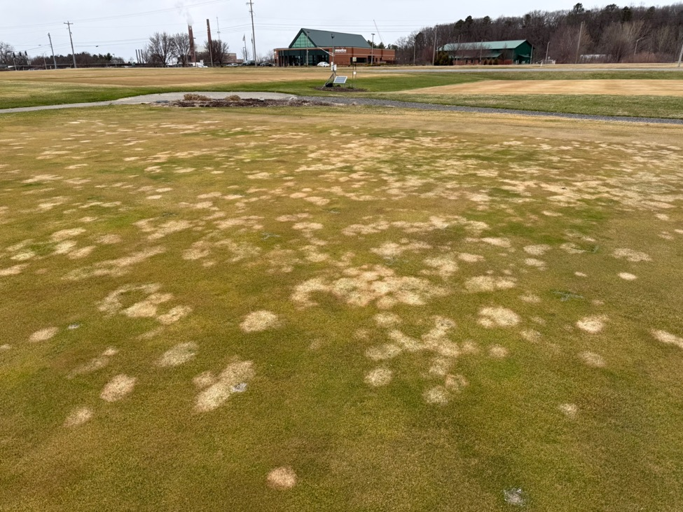

Photo: Annual nitrogen and potassium rate effects on snow mold incidence research area on March 23, 2026.

The third trial is researching the effect of different depths of mulched or non-mulched leaves on turfgrass quality, snow mold development, and measures of soil health. Research was initiated in the fall of 2022 at MSU and the University of Wisconsin and concluded in the spring of 2025 (the plots have been marked for future studies and treatments in 2026). Treatments include untreated, mulched and non-mulched leaves at a depth of 2 inches (buried within the turf canopy) or at a depth of 6 inches (fully covering the turfgrass). To date we haven’t seen any effects with respect to snow mold incidence. Common to both locations were that the 6-inch depth of non-mulched leaves caused significant injury to the turfgrass due to smothering, with less injury on the mulched 6-inch depth of leaves. Preliminary data analysis indicates there were benefits to soil health including increases in soil organic matter at the 10 cm soil sampling depth.

Late Fall Topdressing as a Practice to Mitigate Winterkill

Late fall sand topdressing applications have become a common practice in many regions as a possible deterrent to winterkill. There is little if any data from trials to either support or refute the benefit of these applications. In the fall of 2023 and 2024, topdressing applications were made to putting greens at turfgrass research facilities in Iowa, Michigan, Minnesota, Wisconsin, and Norway and on a golf course in Oregon to determine the effects of late fall sand topdressing. The sand topdressing rates applied were none, 3 ft³ sand /1000 ft² (normal rate), and 6 ft³/1000 ft² (high rate). Topdressing was applied in a single application after the final mowing of the season and before the first anticipated snowfall. Response variable such as surface temperature, percent winter damage and turfgrass quality were assessed within the fall topdressed plots and were compared to plots that were not topdressed. Data were collected after spring snow melt until complete turfgrass green-up.
Results were mixed across diverse locations, but some commonalities were found among treatments in both years. Surface temperatures were higher for the high topdressing rate treatments which may result in increased biological activity for snow mold pathogens. At the Wisconsin location this was in fact the case with more snow mold on the high topdressing rate treatments in the first year but not the second. At the Oregon location, surface temperature and quality increased with topdressing rate, while winter damage decreased with increasing topdressing rates in the first year. At the MSU location in 2025, ice covered the plot area for approximately 5 weeks from January through February. There was no winterkill observed on the creeping bentgrass green but the Poa annua green had some minor injury. The topdressing plots generally had less injury than the plots that were not topdressed.
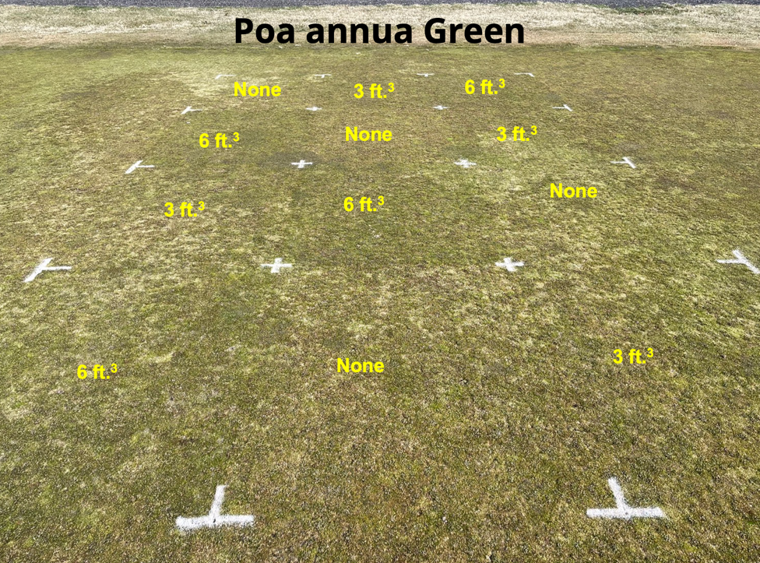
Photo: Topdressing treatments on Poa annua green at the Hancock Turfgrass Research Center on March 19, 2025.

